***Logical Test***

Cara Menjalankan file LogicalTest

1. Pastikan Node.JS sudah terinstall di perangkat
2. Buka command prompt/terminal pada direktori file tersebut berada
3. Masukkan instruksi "node nama_file" lalu klik ENTER
4. Output

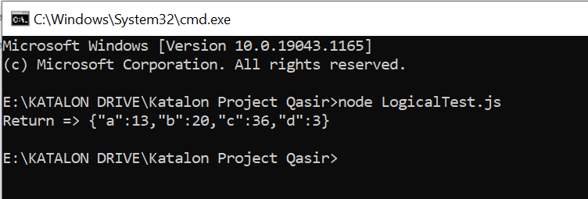

***Automation Framework Test***

How to run it :

1. Open Katalon studio
2. Prepare the file profil image and save on your drive :
3. C:\Users\BRI\ProfilPict
4. You can get that file in: DataImage/ProfilPict
5. Select Test Suites
6. Select which one you login :
7. login with phone number or login with email
8. Must be selected for example :
   1. TC01_Login with Phone Number
   2. TC03_Choose The First Outlet
   3. TC04_ChangeProfil
9. Then klik icon run (play button) and select run with google chrome.
10. Thank you and Good Luck

https://github.com/rhhezkyillma/Project-Qasir

***Quality Fundamental Test***

1. I Give an example of what QA can do to make a good impact on a software development project in terms of communication.

**QA can test the program with several cases from best case to worst case to give input what will happen if the user is doing something that the developer does not expect, QA can also test the security to prevent the attack from hackers that will do unexpected action to the program itself. Result of those testing activities is happening inside the development stage, so if something went wrong it wouldn't impact the production stage and the developer can fix it before it launches to the production stage.**

1. Based on this video make a bug report https://drive.google.com/file/d/1i-ikObwQZfxd4XJ58_BauXrYMkw2cKMq/view?usp=sharing

**Petunjuk: Gunakan aplikasi Qasir di playstore**

**When user want to add bank account, it shows popup that contain form input, but when user want to add account number in “Nomor Rekening” field, it can’t added mode digit after user input 10 digit number. It should be a free text or more digit to be inputted because account number has variative length**

1. Berikut adalah dua struk untuk satu transaksi yang sama. Struk di kiri adalah struk kasbon dan struk yang di kanan adalah struk pelunasan. Temukan bug yang terjadi di kasus ini lalu laporkan dengan format pelaporan yang baik.

**Pada struk kasbon tidak tercetak nomor struk, nomor struk penting untuk pembukuan dan referensi pada saat pelunasan**

**Pada struk kasbon, jumlah nilai ppb tertulis 110.000 seharusnya 55.000, nilai tersebut didapat dari nilai subtotal dikalikan 50%**

**Pada struk kasbon, jumlah nilai service tax 10% seharusnya dihitung dari subtotal barang yang ada, tetapi tercetak 22.000 dimana nilai tersebut adalah hasil yang didapat dari mengalikan jumlah nilai ppb dan subtotal dengan 10%, seharusnya cukup 10% dari nilai subtotal barang.**